**Benefits of Playing Cricket, You Can’t Ignore**

Playing is always fun. Children enjoy it. Young and old enjoy it. We learn easily through play way method. Benefits of playing is immense. There are physical, mental and social benefits of playing any sports. It improves cognitive, physical, social and emotional well-being of a person. Sports can be pursued for improving fitness, as a stress buster or as a career option. In India, you see children playing cricket everywhere, be it the field, in the garden, on the street or in the alley. [**Thetidkes**](https://thetidkes.com/) having best cricket equipment online at best price. You will get best English willow cricket bat, [SS Kashmir Willow Cricket Bat](https://thetidkes.com/product/kashmir-willow-cricket-bat/) online only at Thetidkes. Even There is no doubt, that cricket is the most popular sport not only in India but everywhere in the Indian subcontinent.

**Builds stamina**

Daily practice and training help in building stamina. Cricket being an outdoor sport, it involves a lot sprinting on the vast ground during fielding, bowling and running between the wickets. Regular training would help to keep-up with the fast-paced shorter version of the game, the T20 cricket matches.

**Balance**

A good balance plays an important role in all games. Maintaining a steady balance helps you to run between the wickets, sprinting on your line-up for bowling or helps you to run and throw the ball accurately at the stump or at the wicket to affect a runout. Sturdy balance is essential, as on many occasions, cricket is played at night and the ground may be covered with dew.

**Hand-Eye coordination**

Good hand-eye coordination and batting technique is important to play the game of cricket. It is said that catches win matches. Sharp hand-eye coordination will help in fielding and taking catches. In the shortest form of cricket, these skills play a vital role in winning or losing a game. Hand-eye coordination is a very important skill for enhancing your performance in all forms of cricket, test match, one day Internationals or T20 matches.

**Team work skills**:

Team skills help you to work well with others. Provides flexibility as team members usually complement each other. Selfless team work is needed for playing cricket. Thetidkes will offer you best quality of [cricket equipment](https://thetidkes.com/product-tag/cricket/) to buy online at affordable price. Maintaining good relationship with other players, couches, managers and all other support staff is very important for progressing and accomplishing success.

Some team work skills are -

* Communication
* Active listening
* Accountability
* Taking responsibility
* Leadership skills

**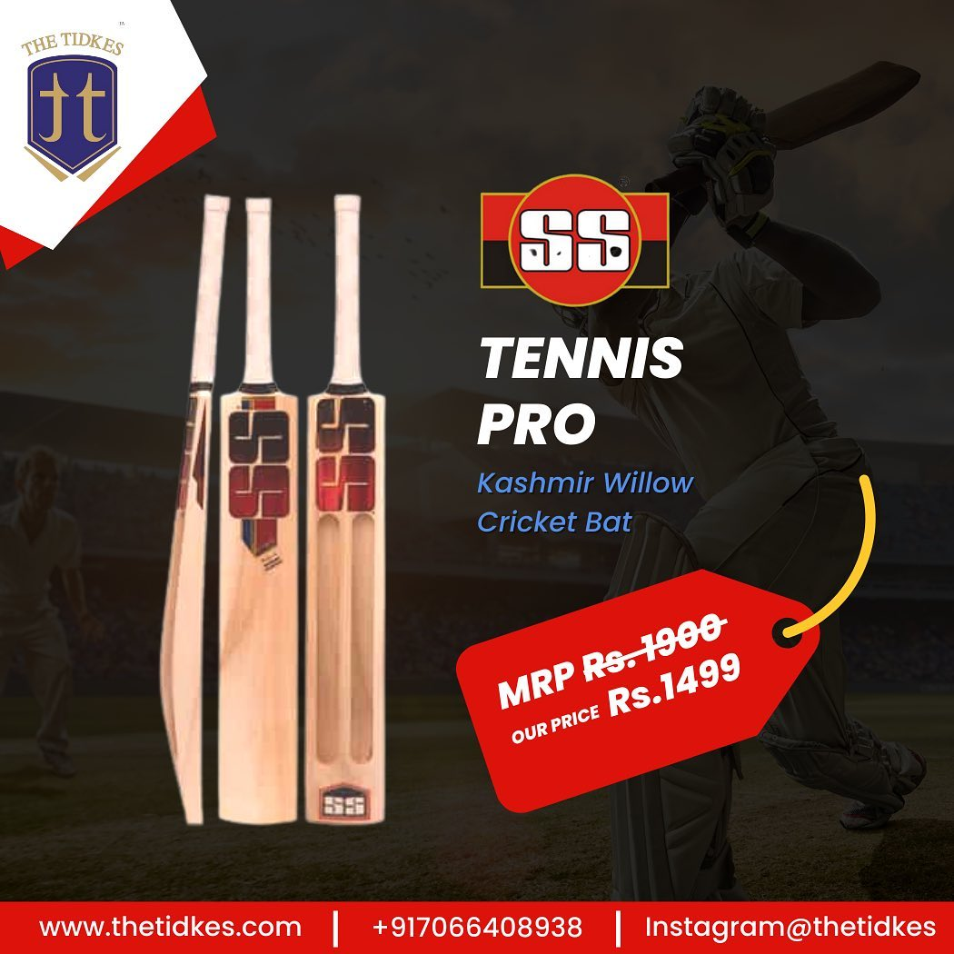**

**Fairness and integrity**

It’s not simply, that the game of cricket is called a gentle man’s game. Respect for rules of the sport, tolerance, integrity and equal treatment of all, are some of the characteristics needed for playing the game. These characteristics are developed in a player on and off the field through experiences, meeting players and legends of the sports.

**Stress buster**

Playing cricket helps you to overcome depression. It helps you to keep calm in time of stress. Cricket encourages you to give your best when you are under pressure to perform. Players become confident and daring to make quick decisions as success and failure is absorbed by the entire team. This provides a cushioning effect on the players, emotionally. Sense of pride and accomplishment are shared by the members equally.

**Improves self-confidence**

To be successful in any sport or in any task that is undertaken, first you need to believe in yourself. Believe in one’s own ability and skills. Practicing basic skills together, will help the team members to improve their performance and thereby help in building confidence. You grow together as a team. Confidence plays a significant role in the team’s success rate. Patience and hard work go a long way. Only being skillful isn’t enough. Consistency in performance pay dividends.

**Social skill**

Social skills are important not only for sports but for day-to-day life as well. Social skills such as cooperation, communication, collaboration are important attributes that provide a strong support to the team members. Being positive in your approach, helping others and guiding new members are skills developed by players in a team. Members of a team learn to express ideas and clarify doubts by asking questions. These social skills, not only builds confidence but they also build a strong bond between the players and enhances their performances. Cricket is a team game which help in meeting new people and making new friends.

You can collect your best cricket bat online from [Thetidkes](https://thetidkes.com/). So go ahead and get the best quality [cricket equipment](https://href.li/?https://thetidkes.com/product-category/cricket/) online from our e-commerce site at a reasonable price. Thetidkes is one of [best online sport store in india](https://href.li/?https://www.thetidkes.com/) that provides original and authentic products. Best sporting brands are also available at the best prices. Thetidkes has the best quality English willow cricket bat and Kashmir willow cricket bat online at an affordable price and even you can have a combo pack also. We have authorized distributors of Cosco, Yonex, Nivia, Spartan, SS, TT, Tennex, Konex and many more Indian and global brands. All sports products and accessories related to Cricket, basketball, volleyball, football, and table tennis are available at THE TIDKES.

You may also visit our website and buy online best quality sports equipment and accessories related to cricket, football, basketball, badminton, volleyball and table tennis.

Carom boards, chess boards, yoga mats and skipping ropes are also available with ‘[THE TIDKES](https://thetidkes.com/shop/)’. Do visit our retail store, TT SPORTS, at Akola, Maharashtra to find a wide range of sports products and accessories. We are authorized distributors of Cosco, Yonex, Nivia, Spartan, SS, Tennex, Konex and many more Indian and global brands.

**You can contact us through social media.**

Instagram: [@thetidkes](https://href.li/?https://www.instagram.com/thetidkes)

Facebook: [Tidke Exporters and Traders Private Limited](https://t.umblr.com/redirect?z=https%3A%2F%2Fwww.facebook.com%2Fthetidkes&t=ODRkNDQwZDNiNjJlYzVmYzA5NzFjYjQwNGE2NjE0NDJlN2RmMjRhNixhMTU3Yzg0YWU4OGIzNzZmZjVjMDFmYTA5NGRlMzIyMzU2MmQ2ZTQ1&ts=1671786578" \t "_blank)

